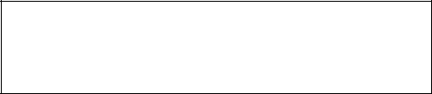

Email ID : [22.shubhagg@gmail.com](mailto:22.shubhagg@gmail.com)

Phone no: +91 - 8860874269

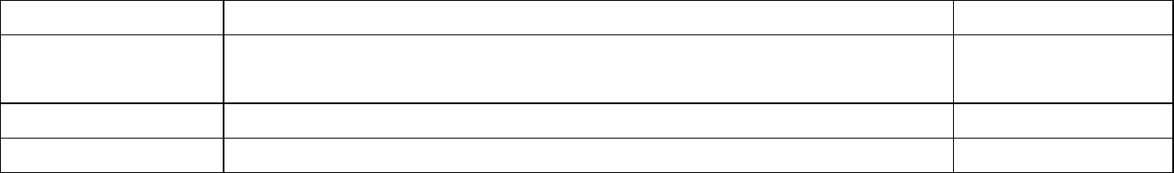SHUBHAM AGGARWAL



**Academic Qualifications:**



**Technical Skills:**

|  |  |  |
| --- | --- | --- |
| **Course** | **College/School** | **% / CGPA** |
| B.Tech in CSE | National Institute of Technology,Delhi | 7.2 |
| (2018-2022) |  |  |
| Class XII (2017) | Suraj Bhan DAV Public School | 80.6 |
| Class X (2015) | Suraj Bhan DAV Public School | 9.4 |

➔ **Languages:** C, C++, Python, Javascript

➔ **IT Constructs:** DS and Algorithms, OOPS,DBMS, Operating System, Computer Networks

➔ **Development tools:** Pycharm, Sci-kit learn, VS code

➔ **Frameworks:** Node.js , React.js,Express

➔ **DB language:** SQL , Mongo DB



**Experience:**

è**Web Development Intern, Rapidex Global Education Consultants(July 20’- Aug 20’):** Worked as a team to develop the full functioning website for their firm. Completed the whole task using the **Reactjs** as the main frontend library and **Nodejs** being used for the backend. **Firebase** was used to facilitate the mobile viewing.

è**Research Intern , NIT Delhi (June 20’-July 20’):** Did a research article on the cancer patients by collecting the database from the National Cancer University and applying different models on them from the **scikit-learn** library. The result was to publish about the seriousness of the disease and the outcome based on the stage at which they were.



**Personnel Projects:**

➔ **Predicting the survival of Titanic passengers**: - Many decision functions were created in an attempt to predict survival outcomes from the 1912 titanic disaster using different parameters like age, gender etc using **schikit-learn** as the main library . Resulted in correctly predicting the follow-up of approximately **94%** of the input data.

* **Mock Github Plaform-** A platform where college students showcase their projects and see what their college peers are working on created using **MERN** stack where users can login on the platform , like and comment on the projects and search projects based on technology stacks.

➔ **Whatsapp Clone:** A Clone which provides an in-depth implementation of whatsapp. Created using the **MERN** web development stack with **Socket.io** and JSON Web Token for security and authentication. **Firebase** was used to enrich the mobile viewing experience.



**Extra-Curricular and Programming Achievements:**

* Keen interest in Problem Solving with 5 star rating on hackerrank.
* Solved over 400 problems on Programming on platforms like SPOJ , Leetcode and geeksforgeeks.
* Deputy General Secretory , Literature Club(NIT Delhi).